**Galileo** Masters 2019: Something special in the Air in Helsinki?

***Published:***

*17 December 2019*

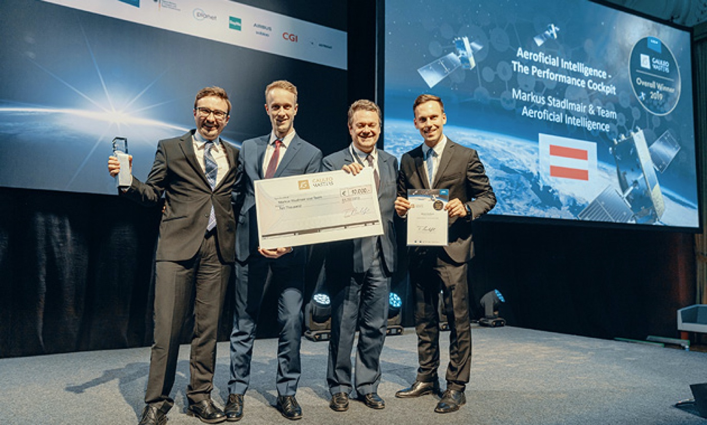

*Participants at this year’s Galileo Masters in Helsinki.*

**Once again, the Galileo Masters – and its sister award programme the Copernicus Masters – was the glittering highlight of EU Space Week 2019 that took place in Helsinki on 3 to 5 December. In its 15th year the Galileo Masters continues to attract the attention of some of the brightest and best minds. Topics submitted to the competition this year ranged through digitisation, big data, the sharing economy and artificial intelligence (AI), amongst others, but all with a common theme: the use of European Global Navigation Satellite Systems (EGNSS) Galileo and/or EGNOS to benefit society.**

The 2019 Galileo Masters attracted some 203 participants reaching entrepreneurs from over 41 countries in Europe and around the world. Since its inception in 2004 the competition has seen a cumulative participation by just under 12,000 individuals submitting 4,587 individual business cases.

In addition to the overall Galileo Masters winner and regional awards, a range of special prizes are also given, including ‘Idea of the Year’ and ‘Start-up of the Year’ and a new prize for 2019 responding to an emerging trend: The Galileo-Copernicus Synergy Challenge.

**Special prizes**

The Gala event took place at the Helsinki Congress Paasitorni centre in central Helsinki on the evening of 4 December. In all, some 31 awards were handed out on the night under the Galileo Masters categories. Master of ceremonies, Bavarian broadcaster and celebrity Claus Kruesken, described the Masters awards ceremony as the “festive highlight of EU Space Week.”

**Read this:** [Performance Cockpit takes overall prize at Galileo Masters 2019](https://www.gsa.europa.eu/newsroom/news/performance-cockpit-takes-overall-prize-galileo-masters-2019)

This year’s new prize, the GSA Galileo-Copernicus Synergy Challenge was presented by GSA Executive Director Carlo des Dorides. Commenting on the event, he highlighted the links that the competition inspired between the GSA and the space applications community by “providing the GSA with a first-hand experience of emerging needs and solutions.” The first ever winner of the synergy prize was the Xylene concept from Giuseppe Benenati and his team. Read more [here.](https://www.gsa.europa.eu/newsroom/news/performance-cockpit-takes-overall-prize-galileo-masters-2019)

Other Galileo special prizes this year included the DLR Artificial Intelligence Navigation Challenge awarded to Pieter Bastiaan Ober of INTEGRICOM for a proposal to analyse the Galileo Signal in Space using AI. The BMVI PRS Applications Challenge was presented to Brandon Bradford of tissEU for his Odin’s Eye idea – a Galileo-enabled PRS tactical drone – that was also the winner of the Bavaria regional Challenge prize.

The University Challenge was announced by Paul Bhatia from the University of Nottingham with the winner, Freewheel – a platform that allows people with reduced mobility to increase their accessibility and inclusion – awarded to Lotfi Massarweh, Deimos Engenharia and their Elecnor team.

The SAWCER concept won the GNSS Living Lab Prize with an idea inspired by a move to a new city, Barcelona, for winner Adrienne Fanning. Her app makes local shops as easy to search as online stores by creating and sharing crowdsourced, geo-localised catalogues.

The internet of Things (IoT) is building to be one of Galileo’s largest markets for applications and the Galileo 5G IoT Challenge award was presented to another idea to help inclusivity by making outdoor sports more accessible to blind or partially sighted people: the WAIBRO belt developed by Katrina Sedlackova and her team at WAIBRO sports.

**New ideas and accelerators**

Fiammetta Diani, Head of Market Development at the GSA presented the Idea of the Year and Start-up of the Year prizes; both of which target entrepreneurship. Idea of the Year went to the CX-GEODRONE project and a joint team from the Universities of Vigo and Oviedo, who also won the Galicia regional prize, for a radar-based drone payload that promised the inspection of underground utilities infrastructure without the need to dig up the road.

**And this:** [uMaze takes Accuracy Matters prize in Galileo Innovation Challenge](https://www.gsa.europa.eu/newsroom/news/umaze-takes-accuracy-matters-prize-galileo-innovation-challenge)

The Start-up of the Year is awarded to a project that is already being implemented in a start-up that is not older than three years and this year was awarded to PODIS - Post Distress Signal. The winning team led by Andreas Alamanos also won the Greek regional prize for this IoT solution-as-a-service concept for automatic crash notification system.

The prestigious EGNSS Accelerator Winners were announced by Pierre Delsaux, Deputy Director-General for Internal Market, Industry, Entrepreneurship and SMEs at the European Commission. Three winners were announced for the valuable incubation prize. First up was MEDeus, aka the drone doctors, represented by Hammad Jeilani and his UK regional winning team that is looking to improve the efficiency of delivering healthcare supplies using drones.

Another double winner was second: Dronetag also won the Czech regional prize for Lukaz Brchl. The Dronetag concept will provide real-time identification for UAVs by leveraging Galileo and IoT technologies.

The third Incubation winner was in fact a triple success for the German Tocsen GmbH team. Tocsen won the Baden-Wurttemberg regional prize, took this Incubation Accelerator win and was on stage again as the single winner of the EGNSS crowdfunding campaign accelerator! Tocsen is a smart crash detection and automatic emergency call system designed to be incorporated in cyclists’ crash helmets.